**PROJECT REPORT**

|  |  |
| --- | --- |
|  | **Picture 6** |

**MILITARY COLLEGE OF SIGNALS**

**WEB ENGINEERING**

**SUBMITTED BY:**

**ASC ABDUL MOIZ QUDDOS**

**PC USMAN AFZAL**

**ASC KALEEM ULLAH**

**PC HAMZA BIN ATIQUE**

**COURSE/SECTION:**

**BESE 25 B**

**SUBMITTED TO:**

**MA’AM NAIMA ALTAF**

**SUBMISSION DATE:**

**04/02/2022**

**OBJECTIVE:**

The main purpose of a Content Management System (relating to web) is to provide the capability for multiple users with different permission levels to manage a website or a section of the content.

**EDITOR:**

* VS CODE

**LANGUAGES/PACKAGES/TECHNOLOGIES USED**

* HTML
* CSS
* JAVA SCRIPT
* JQUERY
* AJAX
* EXPRESS JS
* JADE
* MONGO DB
* COOKIE PARSER
* EXPRESS-SESION

**WEBSITE DETAILS**

* LOGIN PAGE
* ADMIN PORTAL
* FACULTY PORTAL
* HOME PAGE
* PROFILLING SECTION
* RESULTS
* COURSES
* ATTENDEANCE

**LOGIN PAGE (STUDENT):**

CONSISTING OF:

Username

Password

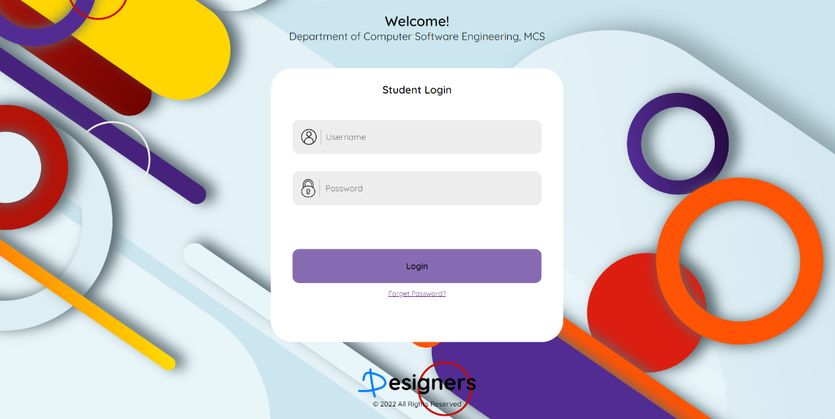

**RESULTS**

On clicking the required course, you can view the result details of that specific course.

e.g., SDA, TW, PE, WEB ENGG, OS

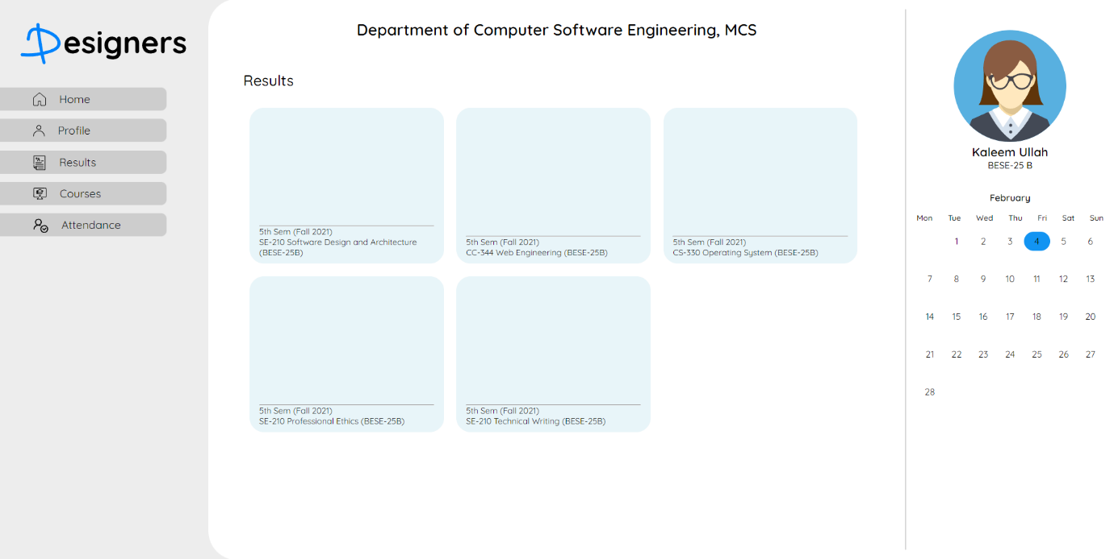

**RESULTS:**

Complete details regarding a specific subject are displayed  
with the specific marks such as Assignments, quizzes ETC

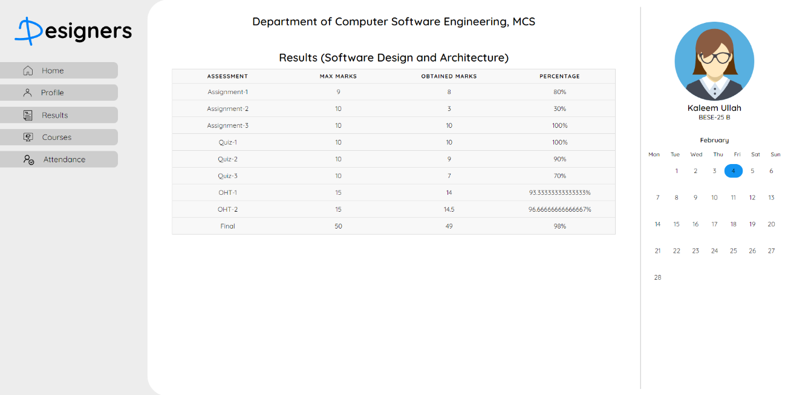

**PROFILE DETAIL:**

Profile details are displayed where one can view there entered details such as:

Email, CNIC,Phone #,Address ETC

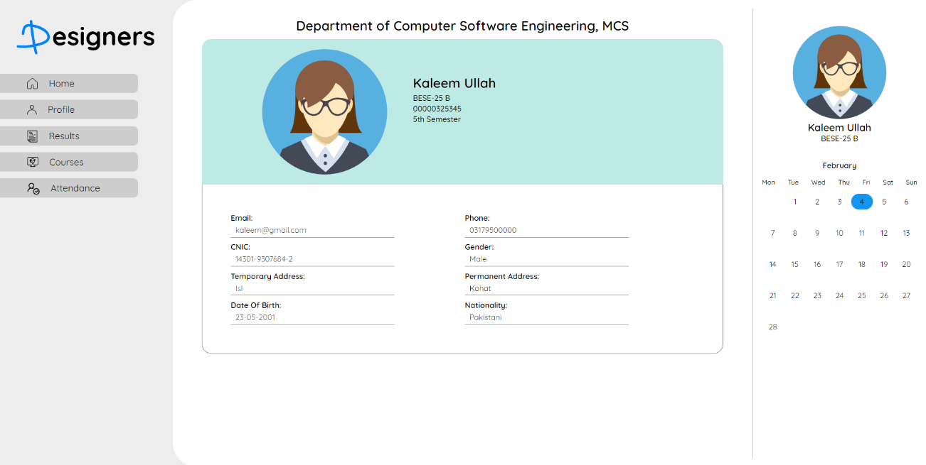

**HOME PAGE / DASHBOARD:**

Enrolled Courses Overview are displayed along with the Alerts and the Notifications.

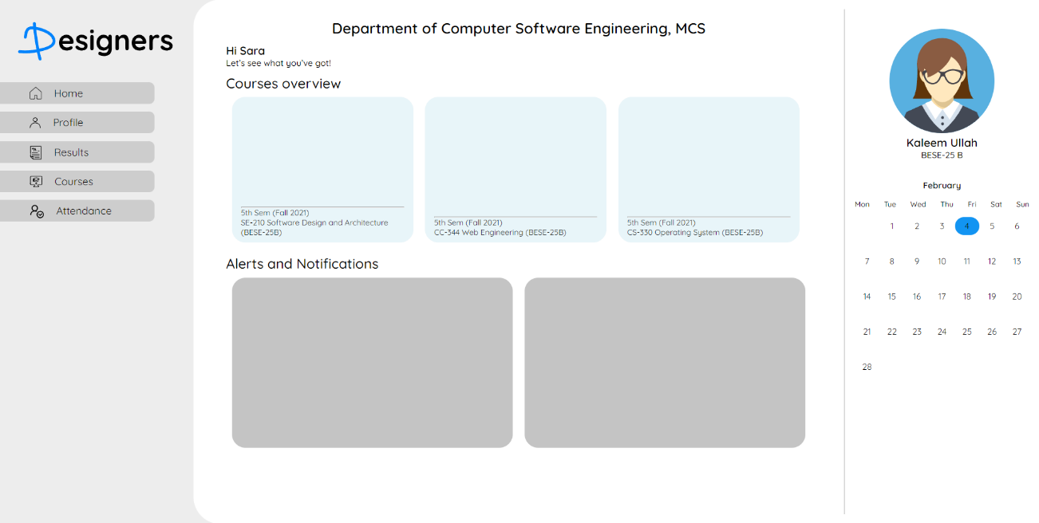

**ATTENDACE OVERVIEW:**

A Minor overview of the attendance of an individual is mentioned in the form of a bar chart. On the bottom you can access the specific required attendance of that specific subject.

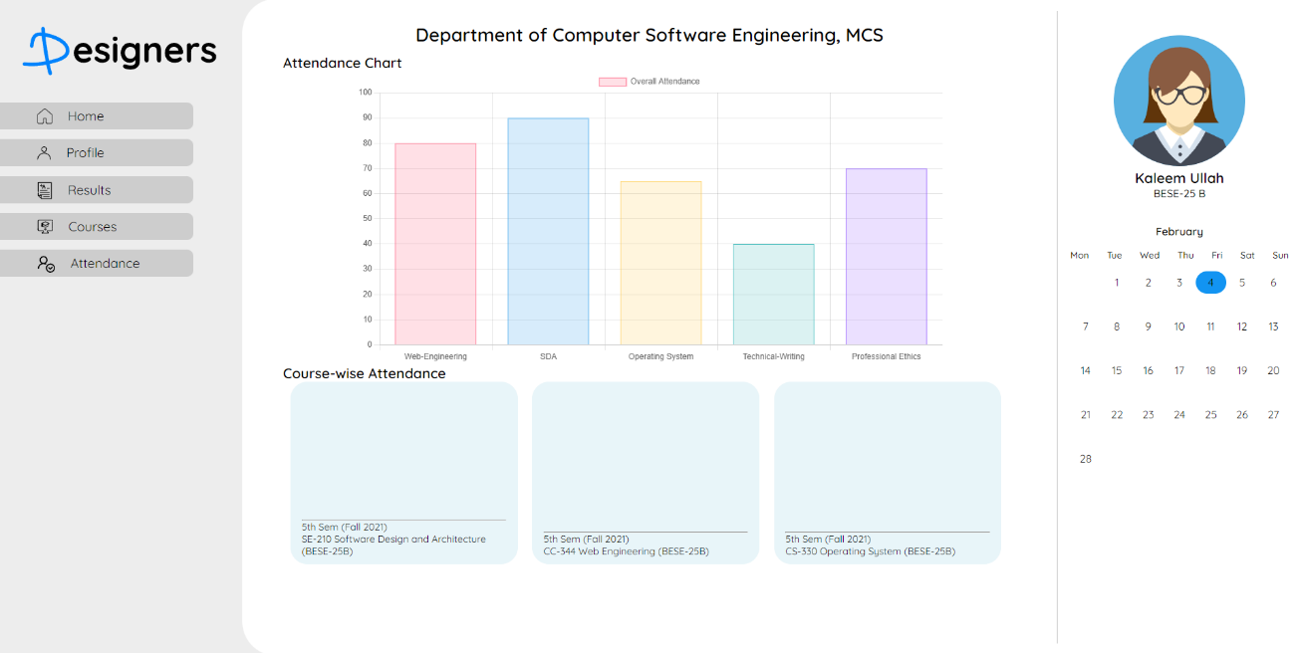

**ATTENDANCE DETAILS:**

After clicking the specific details are mentioned below in form of a table.

**FACULTY LOGIN:**

The main person who updates the data of a student is the faculty member so for that there is also a faculty login page where a faculty member can update the record of a student.

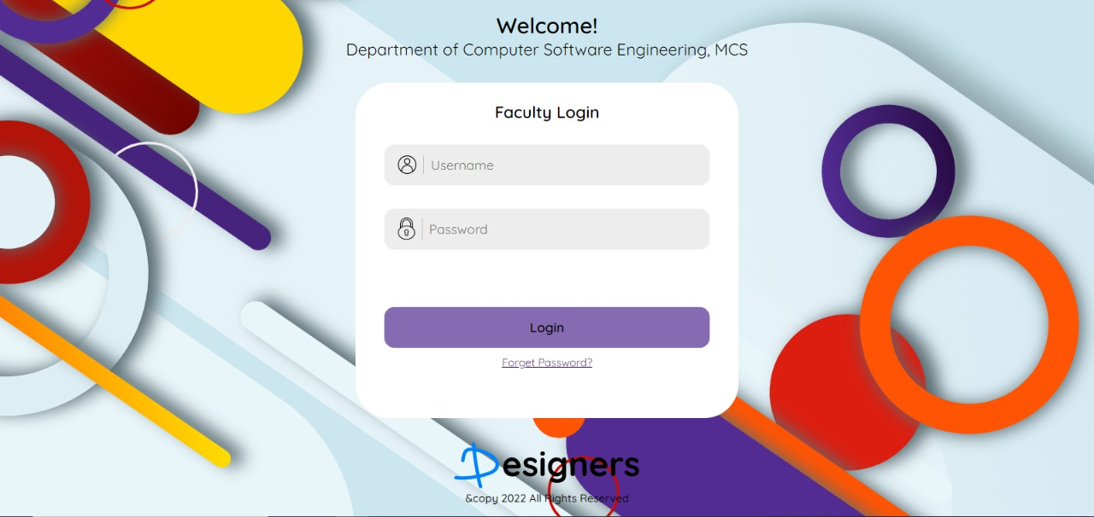

**ADMIN LOGIN:**

There always remain a need of an admin user that can edit both the faculty and the student details, so that there is no technical/departmental issue for the faculty or the student.

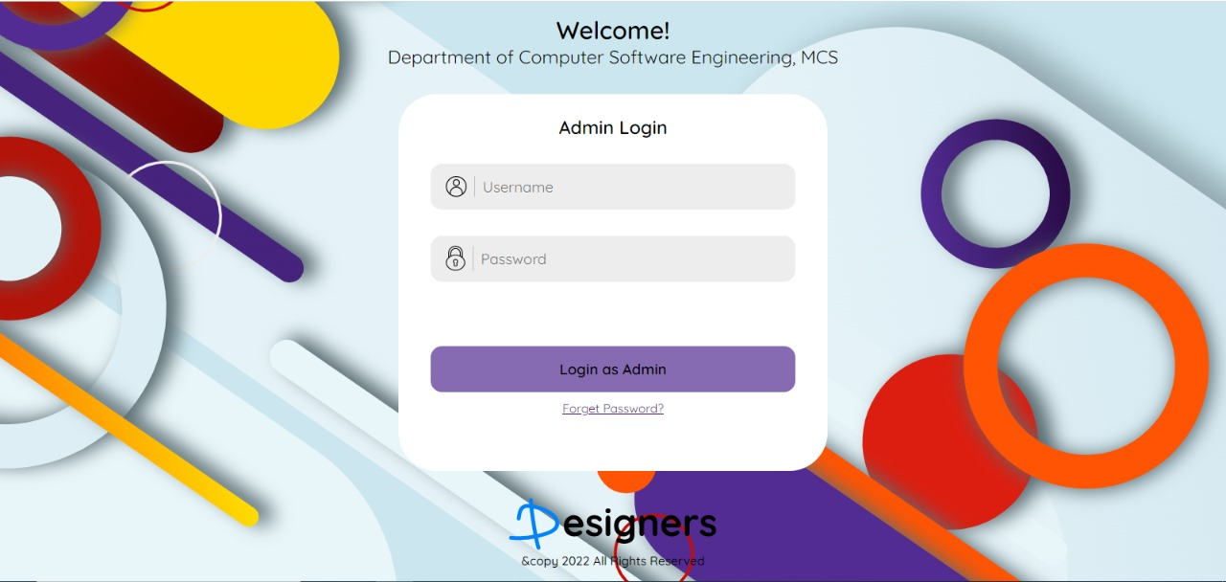

**ADD STUDENT (ADMIN):**

Admin has a the power to add the student to the database , if it was allowed to the system there would have been a lot of users registered that might not been of the same University.

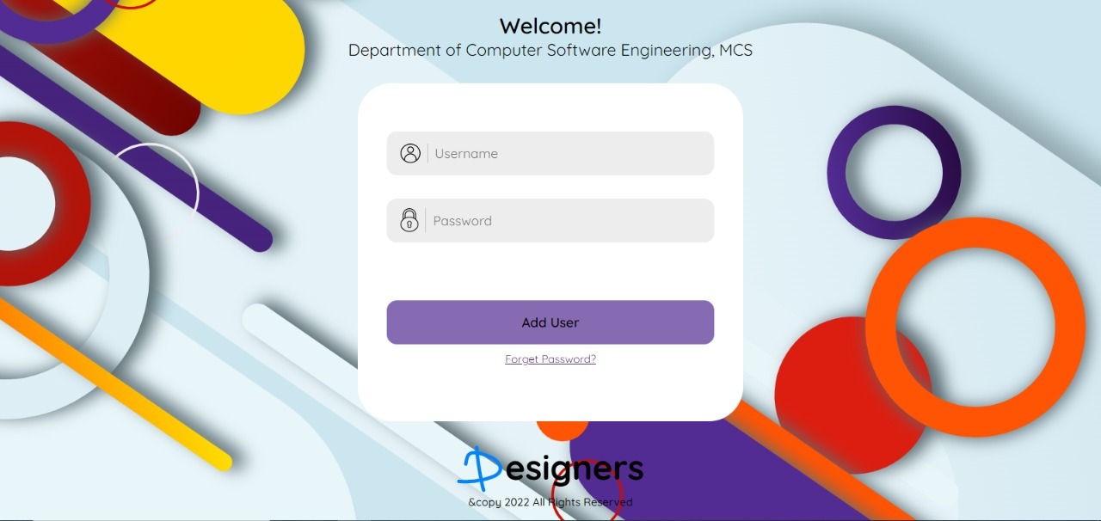

**FACULTY ATTENDANCE DETAIL:**

To keep an update of the student attendance, a page is provided where the faculty can update the student attendance to keep the record.

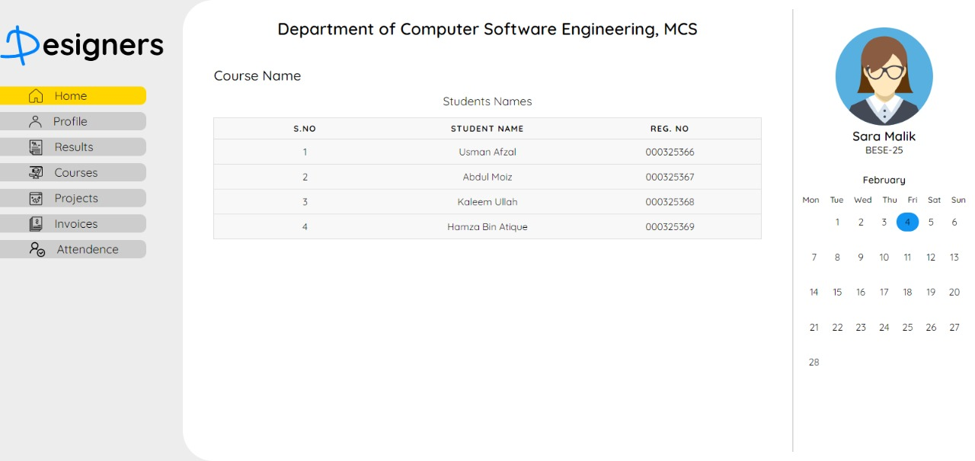

**FACULTY SUBJECT DETAILS:**

Faculty can view the subject details of a student in which they have registered.

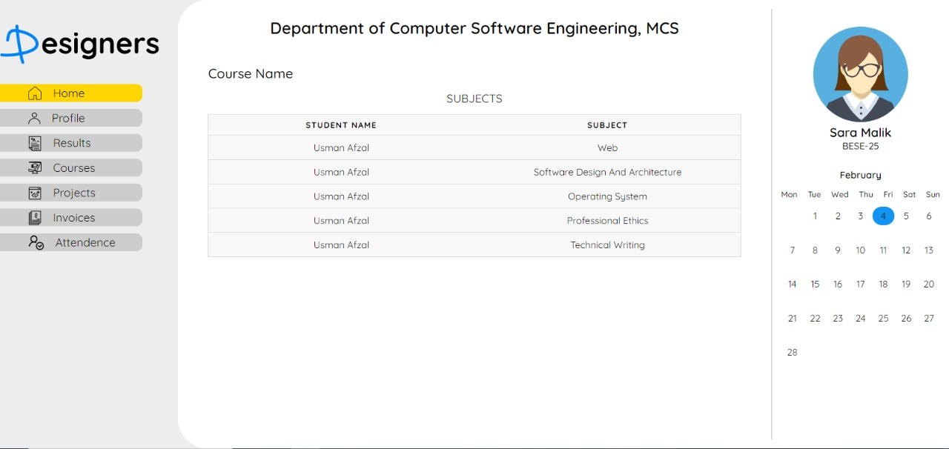

**FACULTY ATTENDANCE CHECK:**To update a student specific attendance, faculty can update the attendance of that specific subject.

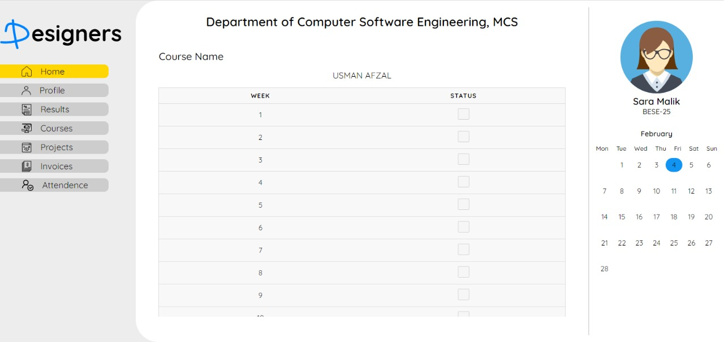

**RESULT SUBJECT WISE ALTERATIONS:**

To daily update the details of the student’s performance in terms of an assignment, quiz, OHT or Final are displayed where the faculty member can update them.

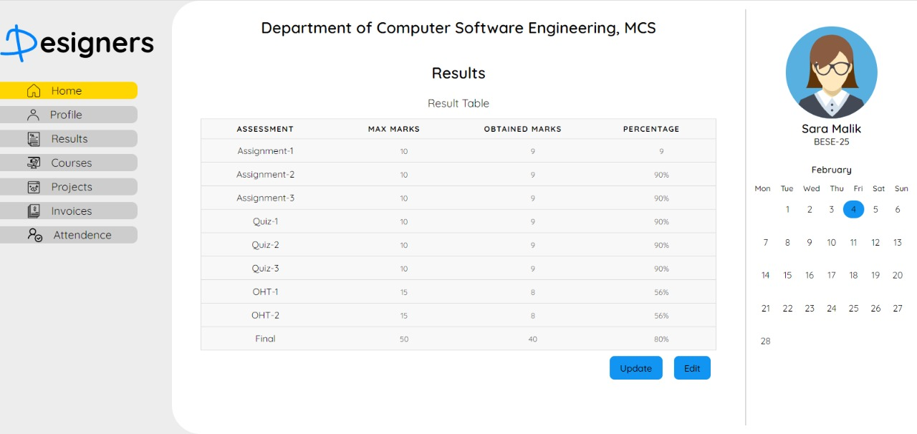

ATTENDANCE DATABASE

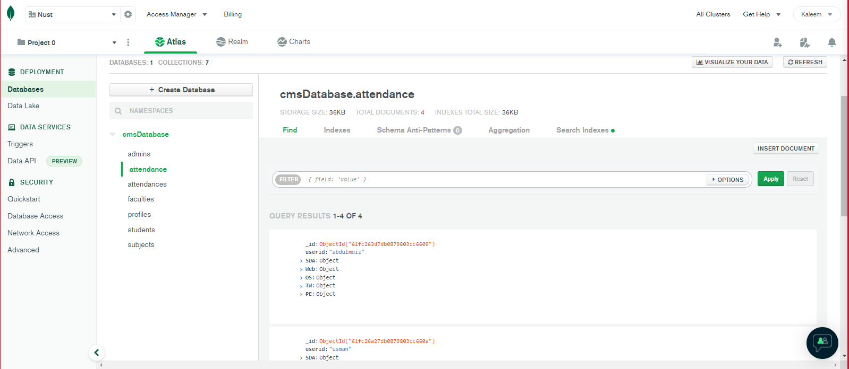

PROFILE DB

